Experiment 5
Compute Measures of Central Tendency and Dispersion Using the State-wise Literacy Rate Dataset in R

PART B
PART B: TO BE COMPLETED BY STUDENTS)

(Students must submit the soft copy as per following segments within two hours of the practical. The soft copy must be uploaded on the ERP or emailed to the concerned lab in charge faculties at the end of the practical in case the there is no ERP access available)

Roll No. 60 | Name: Avdhut Parish Madhavi
Class : SE-C | Batch : C2
Date of Experiment: | Date of Submission :
Grade :

Observation: (Run the programs given above in R studio and paste sceenshots of along with the output)
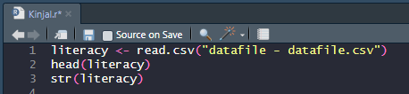
Observation Table:
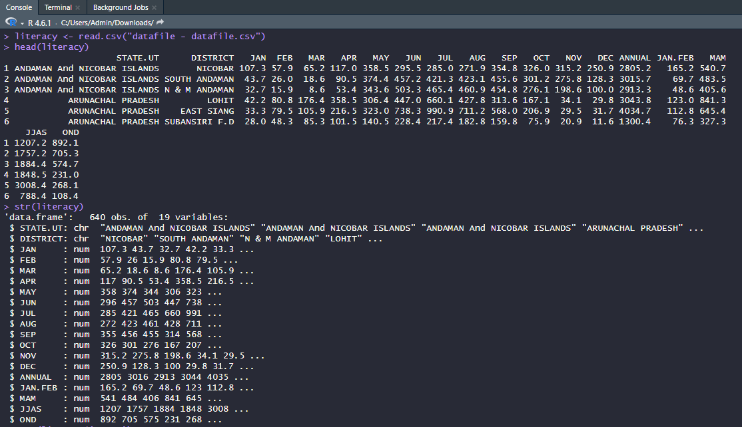

Observation : Paste screenshots of the outputs of above programs mentioned INPUT
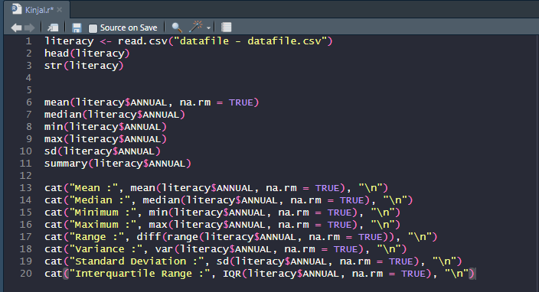

OUTPUTS:
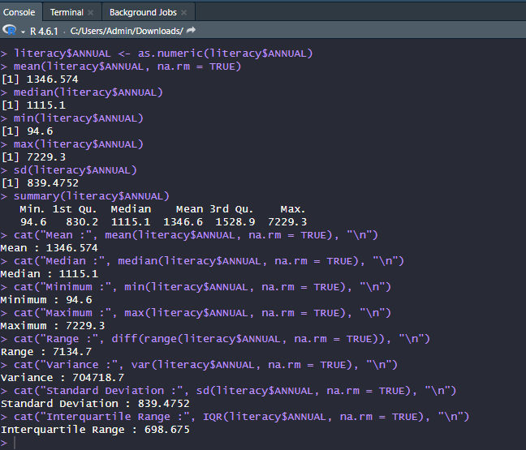

Result: The statistical measures of the ANNUAL literacy data were successfully calculated in R. The mean, median, mode, minimum, maximum, range, variance, standard deviation, quartiles, interquartile range, and summary statistics were generated.

Conclusion: The experiment was completed successfully. R was used to analyze the ANNUAL literacy dataset by calculating measures of central tendency and dispersion, providing a clear summary of the distribution and variability of the literacy values.

Curiosity Questions:

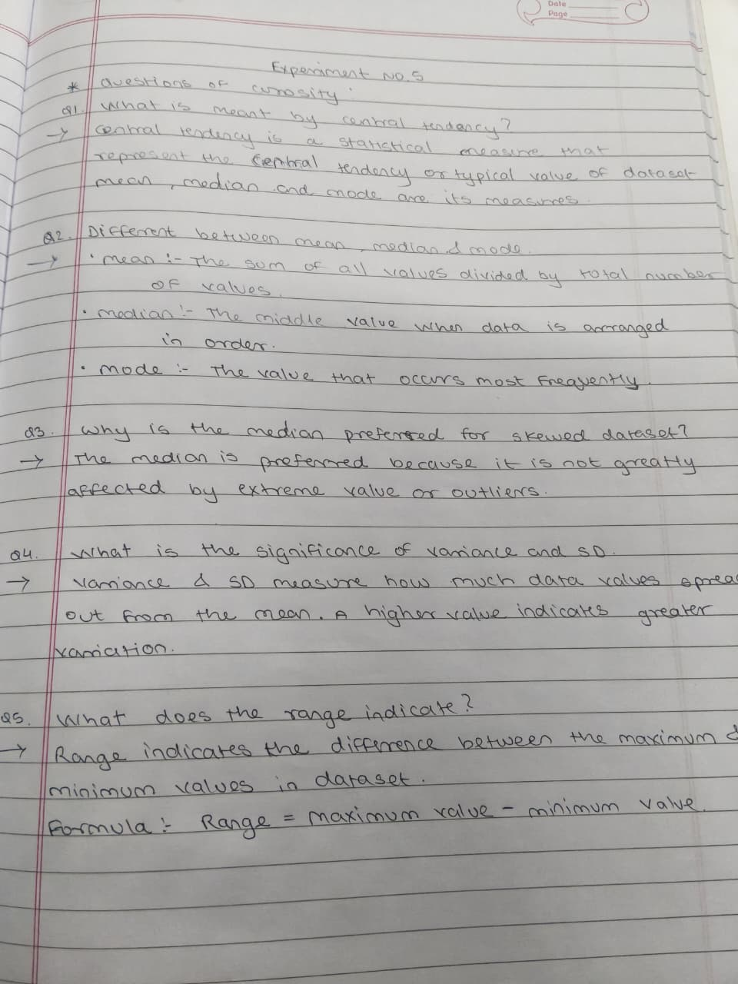

Viva voce Questions:

- What is meant by central tendency?
- Differentiate between mean, median, and mode.
- Why is the median preferred for skewed datasets?
- What is the significance of variance and standard deviation?
- What does the range indicate?
- Explain the importance of the Interquartile Range (IQR).
- Which R functions are used to calculate mean, median, and standard deviation?
- Why is preprocessing necessary before statistical analysis?
- How do outliers affect the mean and standard deviation?
- How can descriptive statistics help policymakers analyze literacy rates across states?

